**Consumer Experience Audit Report**

**At**

**Brookefields Mall, Coimbatore**

**By Team 3**

meenu.s-23MBM030

janani-23MBM017

poorvika sr-23mbm040

vadivoo Seethalakshmi – 23MBM062

Vadhana devi-23MBM063

aishwarya - 23mbm101

**Introduction:**

The purpose of this survey is to gain a deeper understanding of consumer behavior and satisfaction levels within the dining and food court area of Brookefield Mall. Dining and food courts play a crucial role in enhancing the overall mall experience, serving as key attractions that draw in visitors and encourage longer stays. As a prominent shopping destination, Brookefield Mall offers a diverse range of dining options, and this survey aims to assess how well these offerings meet consumer expectations. By exploring various factors such as the frequency and purpose of visits, the quality and variety of food, cleanliness, safety, and overall satisfaction, this study seeks to provide valuable insights that can guide the mall’s management in enhancing the dining experience and addressing any areas for improvement.

**Aim:**   
To assess consumer behavior, preferences, and satisfaction with the dining and food court experience at Brookefield Mall. The goal is to identify key factors influencing customer satisfaction and provide insights for enhancing the overall experience.

**Methodology:**

This survey was conducted at the food court of Brookefield Mall, Coimbatore, targeting a diverse group of consumers. Participants were asked to respond to a structured questionnaire, which included both multiple-choice and rating scale questions. The survey covered various aspects such as demographics (age, gender), frequency and purpose of visits, and satisfaction levels with dining options, food quality, cleanliness, seating availability, safety, and overall experience. The collected responses were then analyzed to identify patterns, trends, and areas for improvement.

**Demographic Overview**

**Age Group Distribution:**

The survey received a total of 70 responses, with the majority of participants falling into the 18-25 age group, representing 64.3% of the respondents. This was followed by the 26-35 age group, which accounted for 25.7% of the responses. Smaller percentages were observed in the other age categories, with negligible participation from those under 18, 36-45, 46-55, and 56 and above. This distribution indicates that the food court at Brookefield Mall primarily attracts a younger demographic, particularly those in the 18-25 age bracket.

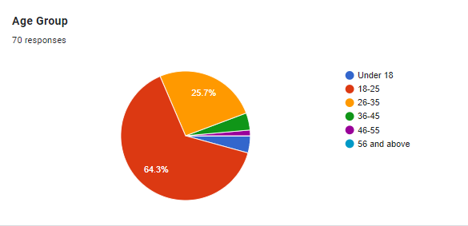

**Gender Distribution:**

The gender distribution of the 70 survey respondents is nearly balanced, with males slightly outnumbering females. Males constitute 51.4% of the participants, while females represent 48.6%. This close gender split suggests that the food court at Brookefield Mall appeals equally to both male and female visitors.

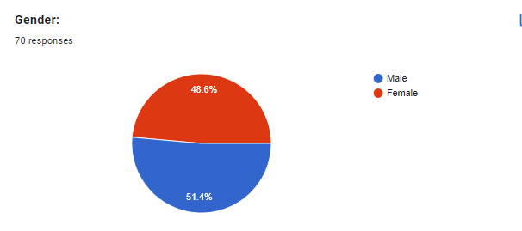

**Visit Frequency:**

The survey collected a total of 70 responses, with the majority of participants visiting occasionally (1-2 times a month), representing 50% of the respondents. This was followed by those visiting regularly (3-4 times a month), accounting for 24.3% of the responses. Smaller percentages were observed among first-time visitors, who made up 18.6%, and frequent visitors (5+ times a month), who comprised 7.1% of the total. This distribution suggests that the venue is most popular among those who visit occasionally, with a significant portion also visiting regularly.

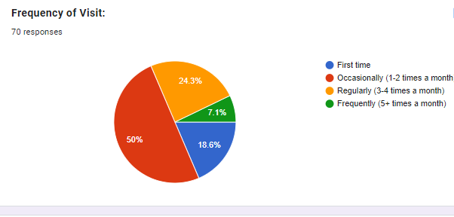

**Purpose of Visit:**

The primary purpose of visits was entertainment, accounting for 45.7% of the respondents. Shopping was the second most common reason, representing 27.1% of visits, followed by dining, which accounted for 17.1% of responses. A smaller group, 10% of the respondents, indicated other reasons for their visit. This distribution suggests that entertainment is the main attraction for visitors, with shopping and dining also being significant factors.

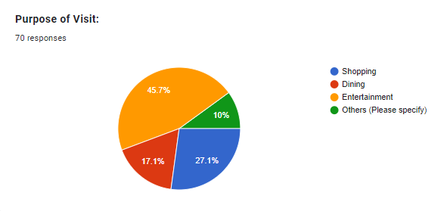

**Dining & Food Court of the Mall**

The majority of respondents are satisfied with the variety of dining options available, with 60% rating it as "Good" and 30% as "Excellent." A smaller portion, 10%, rated the variety as "Fair," while none of the respondents rated it as "Poor." This suggests that the current dining offerings are meeting or exceeding expectations for most visitors. The lack of negative feedback, with no "Poor" ratings, indicates that there are no significant issues with the variety of options provided. However, the 10% rating it as "Fair" suggests there may be room for improvement to cater to a wider range of preferences. Overall, the high percentage of positive ratings highlights general satisfaction and suggests that the dining options are a strong aspect of the experience.

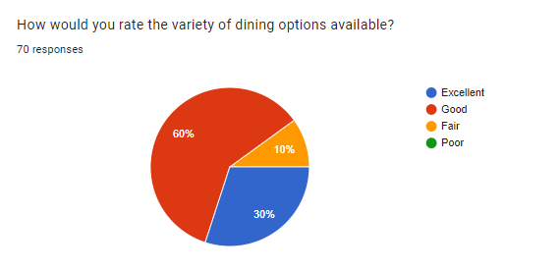

**Food Quality Satisfaction:**

The chart illustrates respondents' satisfaction with the quality of food served. A significant majority, 74.3%, reported being "Satisfied" with the food quality, while 18.6% were "Very Satisfied." A smaller group, 7.1%, remained "Neutral," and no respondents indicated dissatisfaction. These results reflect a strong overall approval of the food quality, with nearly all participants expressing satisfaction. The absence of any dissatisfaction ratings suggests that the food quality meets or exceeds expectations for the vast majority of customers.

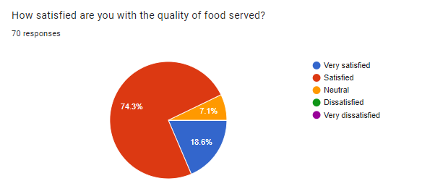

### ****Food Court Cleanliness****

A majority of respondents, 58.6%, rated the cleanliness of the food court as "Good," while 31.4% considered it "Excellent." Only 8.6% of participants rated the cleanliness as "Fair," and no one rated it as "Poor." This feedback suggests that most visitors are pleased with the cleanliness standards, with nearly 90% offering positive ratings. While the small percentage of "Fair" ratings points to potential areas for minor improvement, the overall response indicates that the food court maintains a high level of cleanliness that satisfies the vast majority of its patrons.

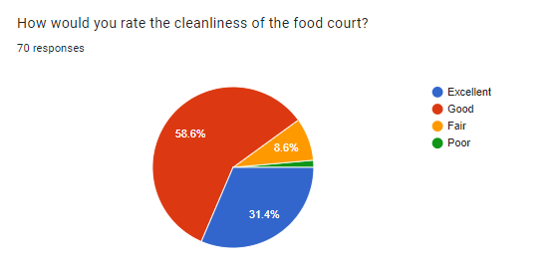

### ****Seating Availability****

Most respondents, 52.9%, rated the seating availability in the food court as "Good," while 37.1% considered it "Excellent." A smaller portion, 10%, felt the seating availability was "Fair," and no one rated it as "Poor." This suggests that the majority of visitors are satisfied with the seating arrangements, with nearly 90% giving positive feedback. The relatively small percentage of "Fair" ratings indicates that there may be occasional challenges with seating, but overall, the seating availability is well-regarded by the majority of patrons.

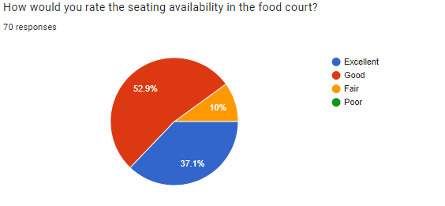

**Safety and security**

Regarding safety, 57.1% of respondents feel safe while visiting the mall, and 35.7% feel very safe. A small percentage, 7.1%, is neutral about their safety. None of the respondents reported feeling unsafe, indicating a generally positive perception of the mall's safety. To further reinforce this sense of security, the mall could implement visible security measures, such as increased patrols or updated surveillance systems. Additionally, regular feedback from visitors can help identify any potential concerns and address them promptly, ensuring that the mall remains a secure environment for all patrons.

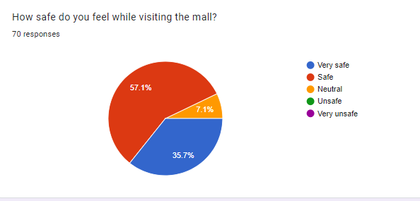

In terms of the presence and visibility of security personnel, 42.9% of respondents rated it as "Very Good," while 34.3% considered it "Good." A smaller portion, 20%, rated it as "Excellent," and only a minimal percentage found it to be "Fair." No respondents rated it as "Poor." These results suggest that most visitors are satisfied with the visibility of security personnel, though there may be room for improvement in ensuring that security staff are more prominently visible to further enhance the sense of safety within the mall.

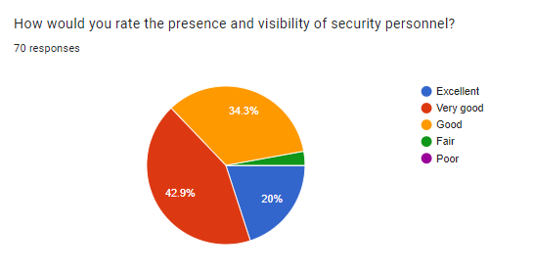

The survey results indicate varying levels of satisfaction with the mall's emergency preparedness, including aspects such as fire exits and medical assistance. Out of 70 respondents, 48.6% are satisfied with the mall's emergency measures. A significant portion, 27.1%, feels neutral about it, while 21.4% are very satisfied. However, a small percentage of respondents expressed dissatisfaction, with 2.9% being dissatisfied and 0% being very dissatisfied. This suggests that while the majority of visitors feel positive or neutral about the mall's emergency preparedness, there is still room for improvement to address the concerns of a small portion of the customers.

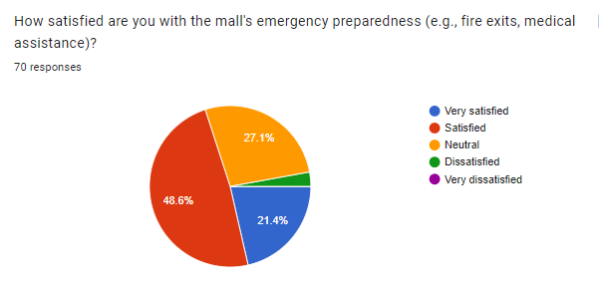

**Overall satisfaction**

The majority of respondents have a positive perception of their overall experience at the mall. Out of 70 responses, 64.3% rated their experience as "Good," and 30% rated it as "Excellent." A small percentage, 5.7%, felt their experience was "Fair," while none of the respondents rated it as "Poor." These results suggest that most visitors are satisfied with their time at Brookefield Mall, with a significant portion expressing high levels of satisfaction.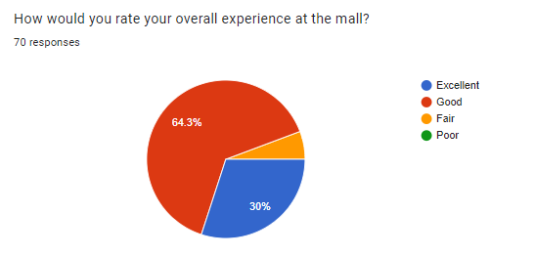

**Conclusion**

The survey results indicate that Brookefield Mall's food court is generally well-received by its visitors, particularly among the younger demographic, with the 18-25 age group being the most prominent. The overall satisfaction levels with the dining options, food quality, and cleanliness are positive, and the mall is seen as a safe and secure environment. However, while the majority of respondents are satisfied with the mall’s emergency preparedness and overall experience, there is room for improvement, especially in areas like seating availability and further enhancing customer safety measures. The insights gained from this survey can guide Brookefield Mall’s management in making targeted improvements to enhance the customer experience, thereby increasing visitor satisfaction and loyalty.